Upper Back, Shoulder & Neck Corrective Exercises
Self Myo Fascial Release
Do these exercises whenever you can, ideally once per day for 15 minutes. Also perform these stretches before exercise as a warm up or post exercise as cool down and before static stretching.
Hold on very tender areas for 30-90 seconds to help reduce lumps.
Focus on these areas for your condition.

Latissimus Dorsi thoracic Spine
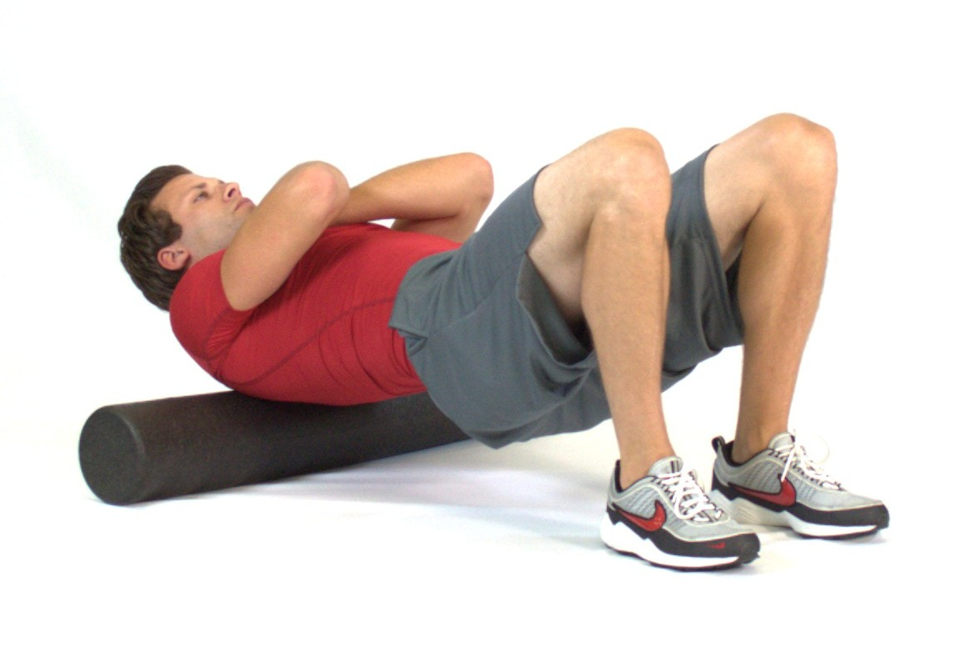
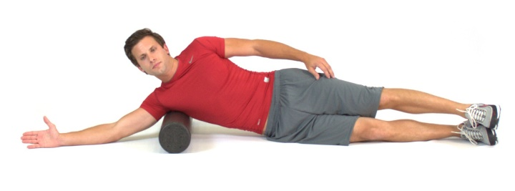
Pectoralis Major and minor
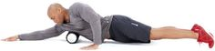

Ball rolling Levator Scapula and upper trapezius and pec major
Often tight pectoral muscles can aid shoulder weakness and tenderness. Try to roll a tennis ball or similar below your collar bone, front of shoulder joint and the fleshy part in front of your armpit crease. Try to hold on any tender areas until the pain subsides. Do not roll your breast tissue.

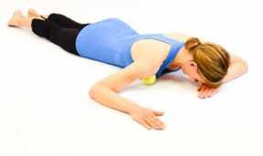
Use a tennis ball or similar and place this against a clear wall and between your shoulder blades or at the top of your shoulder.
Gently roll over the ball and hold on any tender areas until pain subsides.
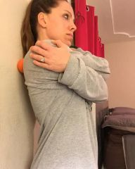
Static Stretches: 30 second hold/ 6-10 second isometric contraction, 30 sec hold
Upper Traps Latissimus Dorsi
Pectorals Levator Scapula
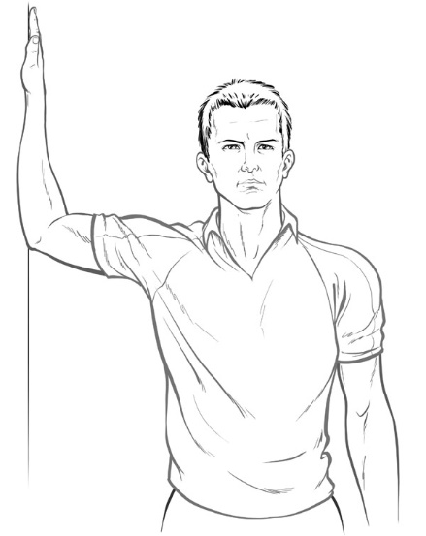
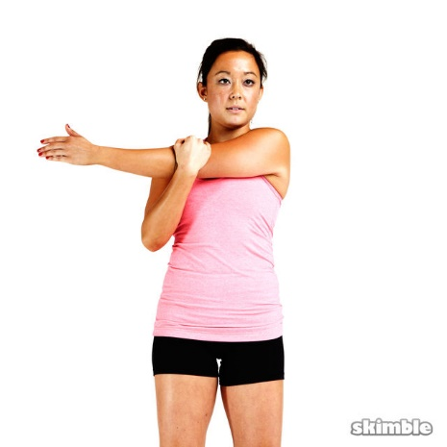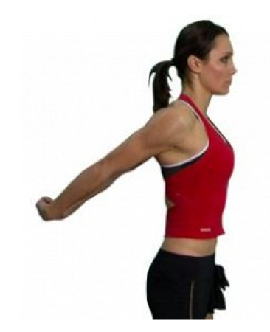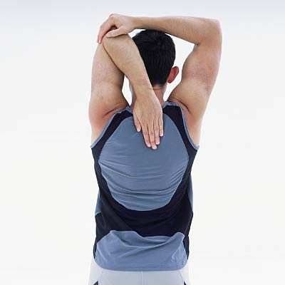

Movement Preparation and Strengthening
Thoracic Rotations:
Chest Openers
This exercise helps to release tight chest muscles and mobilise your upper back as well as stretching through the hips and lower back. Aim to do 6 openers on each side, everyday.
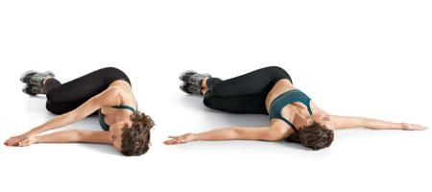
Helps mobilise upper back and chest. Aim for at least 6 repetitions each side, do one side first then the other. Use for pre-exercise warm up and general stretching.
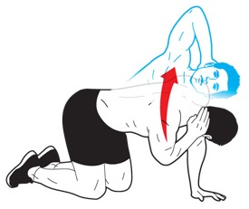

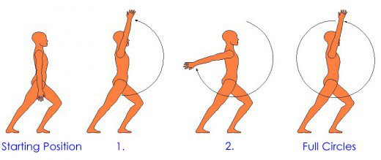
Arm Circles
Circling the arms is a good way to mobilise the shoulder joint and increase full range of movement. Try to do this one arm at a time 5-6 times on each side.
Do this, and the exercises above, every day to see a quicker improvement.

Strengthening to improve posture
These exercises below are aimed at helping to improve the strength of the main muscles responsible for upper back posture and shoulder function. Aim to do 6 to 8 repetitions of each exercise at least 3 times per week. Alternative equipment such as small lightweight dumbbells can be used instead of a band.
Rhomboid strengthening Rowing for scapula retraction

In addition to these exercises and stretches, I strongly recommend that you regularly attend either some form of flexibility class i.e. Pilates in addition to a resistance training class, preferably a kettlebell training class or circuit training. Please see my website www.iam-fitness.co.uk for further information regarding the classes I run.
You must aim to foam roll or stretch at least 3 times per week, of which stretching post exercise can be 1 of your stretching sessions per week.

