Foot and Ankle Corrective Exercises

Self Myo Fascial Release
Do these exercises whenever you can, ideally once per day for 15 minutes. Also perform Pre Exercise as a warm up or post exercise as cool down and before static stretching.

Hold on very tender areas for 30-90 seconds to help reduce lumps.
Focus on these areas for your condition.
Lateral Gastrocnemius/soleus Peroneal Muscles (Supporting)
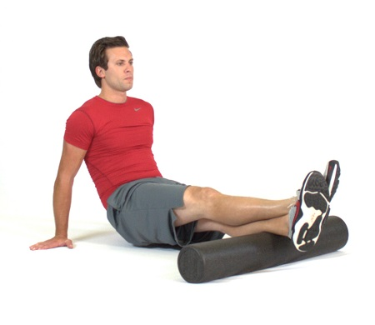
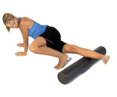

Hamstrings TFL: fleshy muscle at top of IT band
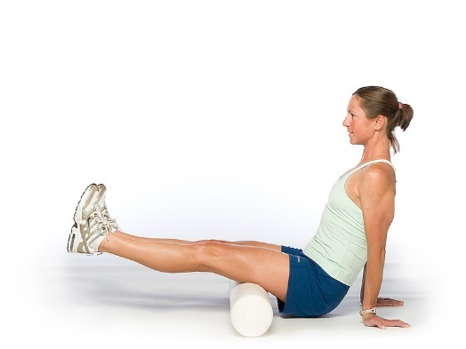
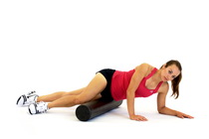

Static Stretches: 30 second hold/ 6-10 second isometric contraction, 30 sec hold

Gastrocnemius Soleus
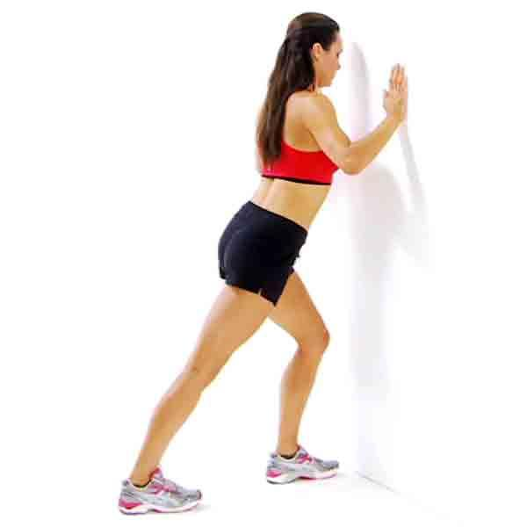
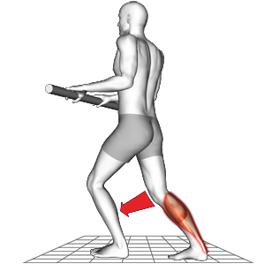
Biceps Femoris TFL: Tensor Fascia Latae
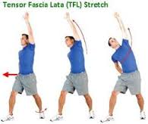

Isometric Activation and Strengthening
10 to 15 reps, 1 -2 sets

Resisted plantar and dorsi flexion Resisted inversion and eversion
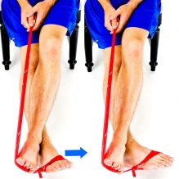
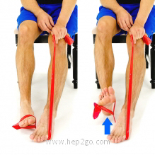

Medial Gastrocnemius Medial Hamstring
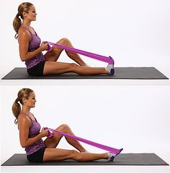
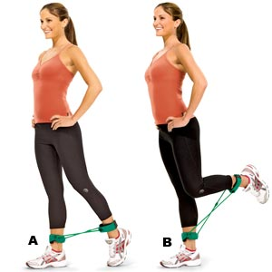

Dynamic Movement and Balance
10 to 15 reps under control, 1 to 2 sets
Knee lift Lunges Single leg squat reaches
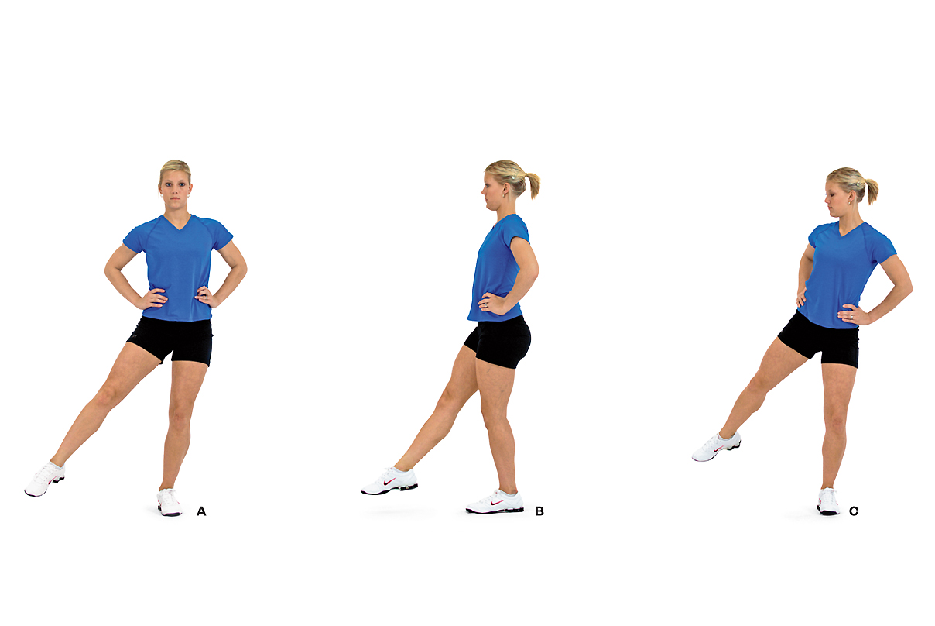
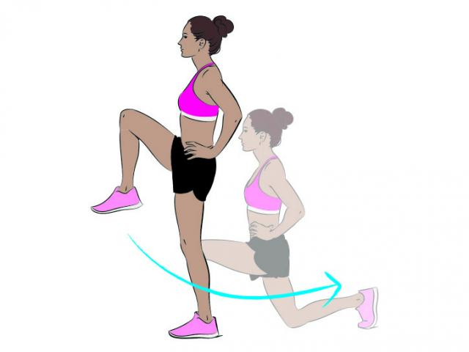

Step up with knee lift Heel toe raises
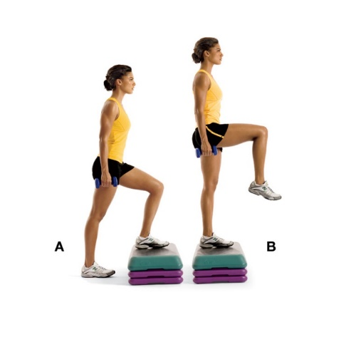
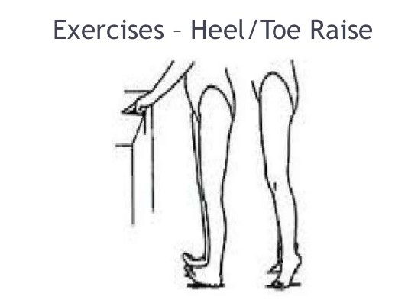
In addition to these exercises and stretches, I strongly recommend that you regularly attend either some form of flexibility class i.e. Pilates in addition to a resistance training class, preferably a kettlebell training class or circuit training. Please see my website www.iam-fitness.co.uk for further information regarding the classes I run.
You must aim to foam roll or stretch at least 3 times per week, of which stretching post exercise will class as a 1 of your stretching sessions per week.

