Anti-spasm and warm-up exercises
Healthy back and Strong Core
Exercise: area of body | Reason why | Exercise example
Anti-spasm exercise on lower back muscles (quadratus Lumborum) | This exercise will help release the tightness in your lower back | 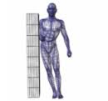  Perform 3 sets of 10 glides on each side.
Mobility stretching and movement preparation: rhomboids, mid back, thoracic spine | Aims to improve posture, increase mobility in your mid and upper back. It will help pull your shoulders back. | 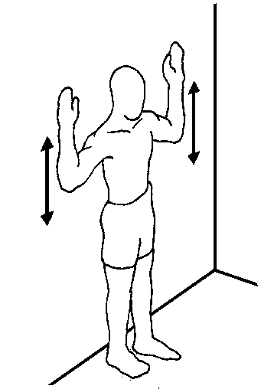  Slowly press your arms over your head. Ensure heels, buttocks, shoulders and head touch the wall
Thoracic spine and mid back mobility warm up | To reduce tightness in your mid back and increase range of movement in your spine. This will help all your back muscles to be engaged and work more effectively during exercise | 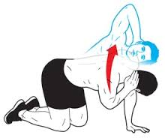
Rhomboids, traps; shoulder joint (rotator cuff); chest (pectoralis major, minor)  Anti-spasm | Your posture assessment showed forward leaning shoulders and head. This will help activate the back muscles needed to pull your shoulders back. Tight chest muscles will increase their range. Hold 20% strength for 20 sec x 4 x 4 per day | 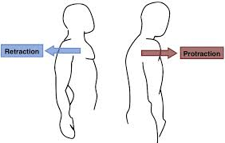
Hamstring activation and dynamic stretch;  Lower back; calves | Active straight leg raise (SLR) was an area of concern. Prepare for exercise by actively moving each leg into the SLR position, alternating.  Increases mobility in hamstrings, lower back and calves. | 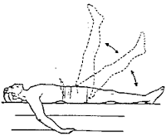
Hamstring and calves mobility | Will help increase range of movement at the ankle, knee and hip joints. Requires additional balance and strength in standing leg | 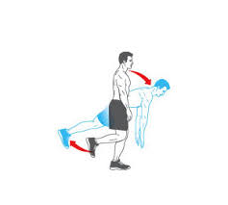
Lower back knee rolls | To loosen lower back muscles, activate hip and lumbar joints | 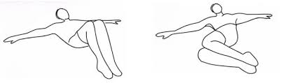
Shoulder rotations with Thera band | Helps increase mobility around the shoulder joint and can help strengthen surrounding muscles. | 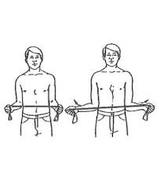
Shallow warm up squats | Assist in mobilising quadriceps; hip flexors; gluts; hamstrings; calves and lower leg muscles | 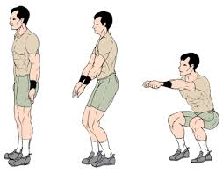
Shallow lunges with rotation | Mobilisation of hip, knee, ankle joints and major leg muscle groups; mobilisation and coordination of upper and lower body | 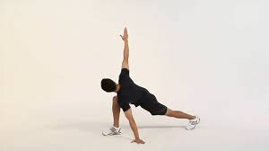
Core activation (abdominals and back) | Core warm up and engagement to assist in strengthening, posture and movement improvement. | 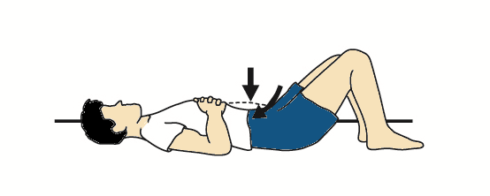

In addition to these exercises and stretches, I strongly recommend that you regularly attend either some form of flexibility class i.e. Pilates in addition to a resistance training class, preferably a kettlebell training class or circuit training. Please see my website www.iam-fitness.co.uk for further information regarding the classes I run.
You must aim to foam roll or stretch at least 3 times per week, of which stretching post exercise will class as a 1 of your stretching sessions per week.

Static Stretches to assist post exercise
Recovery and increase flexibility

Body and Muscles stretched | Reasons why + tips | Example of exercise
Gluts, IT band, lower back, chest | An excellent all over body stretch to maintain flexibility in lower back and chest.  Aim to keep opposite shoulder on the floor to gain maximum range | 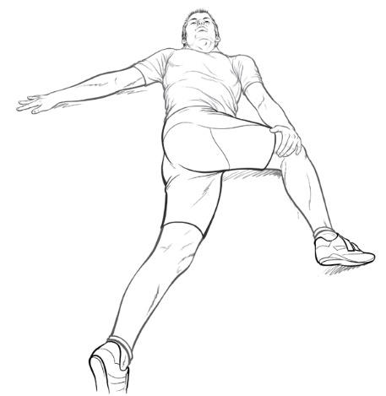
Gluts and lower back | This may be an easier stretch position; aim to keep bottom on floor | 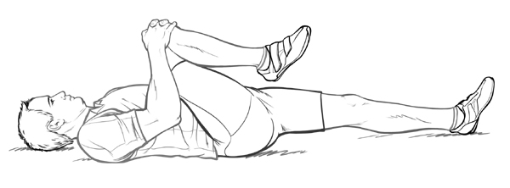
Hamstrings, calves, soleus | Important to increase range of movement and extend your tight hamstrings. Care re locking knee – keep a bend. | 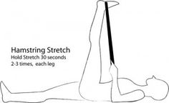
Quads (thigh), hip flexors, knee joint, some lower leg | Standing quad stretch can be done laying down on side, if preferred | 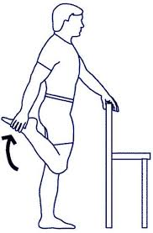
Calf and soleus muscles, Achilles tendon | Although the warm up exercises include this stretch it is important to regularly maintain muscle lengthening | 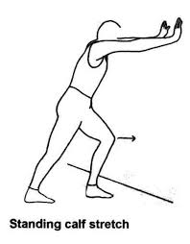
Shoulder muscles including deltoids, triceps, upper back | Important to keep range of movement in the shoulder joint to reduce risk of injury | 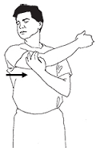
Mid and upper back cat stretch | Emphasis on mid and upper back stretch; can also move from side to side to lengthen tight side back muscles | 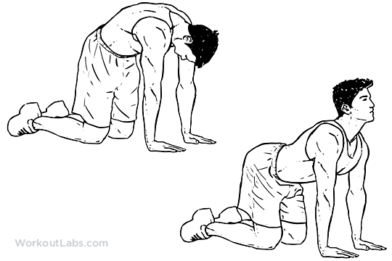
Trapezius (tops of shoulders), neck muscles: scalenes, SCM | To create a more effective stretch – try to pull away in the opposite direction with approximately 20% force | 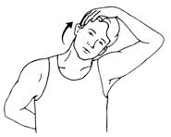
Pec muscles, shoulders, upper arms | Important to keep your chest lengthened to avoid any further pull forward on your shoulders and upper back | 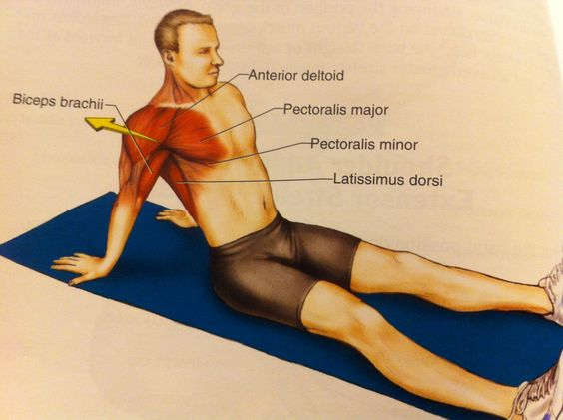
Triceps and front of shoulder joint muscles | Aim to keep head looking forward and arm straight by side of your head. Towel or band can be used to stretch between hands. | 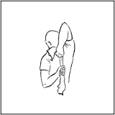

In addition to these exercises and stretches, I strongly recommend that you regularly attend either some form of flexibility class i.e. Pilates or certain types of Yoga in addition to a resistance training class, preferably a kettlebell training class or circuit training. Please see my website www.iam-fitness.co.uk for further information regarding the classes I run.
You must aim to foam roll or stretch at least 3 times per week, of which stretching post exercise will class as a 1 of your stretching sessions per week.

